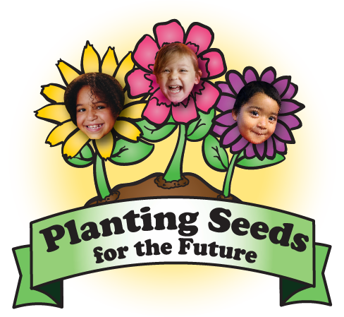
Old Mill Center Dinner & Auction

We are all about GROWING! From the very beginning, the dream has been to ensure that all kids get a fair chance to succeed. Sometimes, though, to make dreams come true takes magic!

We believe every child is entitled to the best start in life, even if their family is struggling.
Whether it’s through our educational programs, prevention programs, home visits or mental health services, Old Mill Center cares for those who need it most.

Saturday, May 4, 2019. CH2M Hill Alumni Center

We need your support to help us meet those needs. We need more fertilizer in our
Garden!
Some of the highlights of our work in the past year include: over 350 children served through prevention and intervention of abuse situations and early education; over 375 children served with Mental Health Services; nearly 2300 home visits to assist children and their families; and, over 5800 hours of counseling sessions. This is a BIG year for us as we prepare to expand our Relief Nursery Classroom program in to South Benton County! We are committed to collaborating with community partners to meet the diverse needs of families.

We strive to engage the entire family and build strong foundations for future success –
We don’t just plant the seed – we nurture it to full bloom!

While our history of local service to children reaches back to 1977 with the founding of our Integrated Preschool, it is the future we are focused on – creating change for those struggling, bolstering the chance for everyone to reach their best potential – to make their “Magic” happen. Please dig in to your tool belt, support our celebratory evening and make an important difference in the lives of our neighbors, our community.
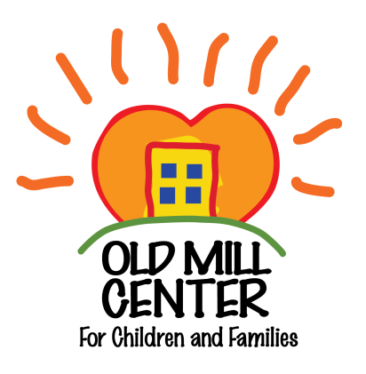

Support the Annual Dinner & Auction as a sponsor.
Help us sow more seeds!

