39th Annual Dinner Auction
Saturday, May 4th, 2019
A celebratory evening of great people, great fun, great food and most importantly, great fundraising!

$500 Auction Sponsor
- 4 reserved seats at the auction
- Listing in program as a sponsor

$1000 Auction Table Sponsor
- Table of 8 reserved seats at the auction
- Listing in program as a table sponsor
- Listing as sponsor for event on Old Mill web site and in newsletter

$1500 Paddle Sponsor
- Company name and logo displayed on back of Paddle (350)
- 4 reserved seats at the auction
- Listing in program as Paddle Raise Sponsor

$2500 Auction Silver Sponsor
- Table of 8 reserved seats at the auction
- 1 Complimentary bottle of wine at table
- ¼ page article or ad in auction catalog
- Listing in program as Silver sponsor
- Listing as sponsor for event on Old Mill web site and in newsletter

$5000 Auction Gold Sponsor
- Table of 8 reserved seats at the auction
- 2 Complimentary bottles of wine at table
- ½ page article or ad in auction catalog
- Listing in program as Gold Sponsor
- Listing as sponsor for event on Old Mill web site and in newsletter

$10,000 Auction Platinum Sponsor
- 2 Tables of 8 reserved seats at the auction
- Unlimited Complimentary bottles of wine at table
- Full page article or ad in auction catalog
- Front Cover Acknowledgement on Auction Catalog
- Logo and Acknowledgment on all Auction mailings
- Gift with company logo given to each attendee
- Listing as sponsor for event on Old Mill web site and in newsletter

Old Mill Magic: Planting the Seeds for the Future
Old Mill Center for Children and Families
2019 Dinner & Auction Sponsorship Form

Name _____________________________ Company Name _________________________

Address____________________________________________________________________

City_______________________________ State____ Zip____________________________
Home phone_________________________ Business phone_________________________
Fax_______________________________ Email________________________________

Sponsorship Level $ _____________________

One payment today ____Check ___VISA/MC ___Discover

VISA/MC #__________________________________________ Exp. Date___________

I plan to pay this in (circle one) 1 2 3 4 installments dated as follows:

Date/Amount Date/Amount Date/Amount Date/Amount
___________ ___________ ___________ ___________

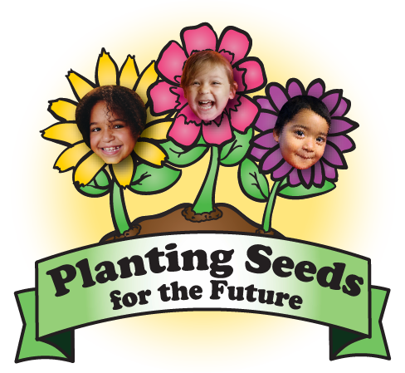
Thank you for your support!

Please mail form & payment to:
1650 SW 45th Pl
Corvallis, OR 97333

Contact:

Kate Caldwell, Development Manager
541-757-8068 ext. 144
kate_caldwell@oldmillcenter.org

